
USN | 1 | M | S

(Autonomous Institute, Affiliated to VTU)
(Approved by AICTE, New Delhi & Govt. of Karnataka)
Accredited by NBA & NAAC with ‘A+’ Grade

SEMESTER END EXAMINATIONS – MAY 2022
Program | : | B.E. : Common to all Programs | Semester | : | I
Course Name | : | Basics Civil Engineering and Mechanics | Max. Marks | : | 100
Course Code | : | CV101 | Duration | : | 3 Hrs

Instructions to the Candidates:
- Answer one full question from each unit.
- Any missing data may be suitably assumed.

 |  | UNIT- I
1. | a) | Explain the scope of following fields of Civil Engineering:  - Geotechnical Engineering  - Environmental Engineering  - Structural Engineering  - Transportation engineering. | CO1 | (10)
 | b) | Discuss the desirable properties and uses of timber and RCC. | CO1 | (10)
2. | a) | Explain the impact of infrastructural development on the economy and environment of a country. | CO1 | (10)
 | b) | What is concrete? Discuss the properties and uses of PCC and PSC. | CO1 | (10)
 |  | UNIT – II
3. | a) | Define force. Explain the types of force systems. | CO2 | (10)
 | b) | Determine the resultant of coplanar concurrent system shown in the Fig.3(b).  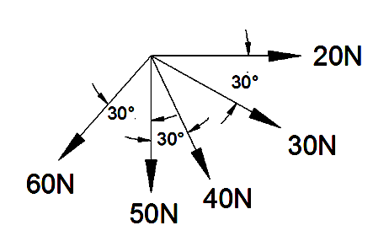  Fig.3(b) | CO2 | (10)
4. | a) | Define couple. Discuss its characteristics. | CO2 | (10)
 | b) | A system of forces is acting on a rigid beam as shown in the Fig.4(b). Reduce the system to:  - a single force  - a single force and a couple at A  - a single force and a couple at B  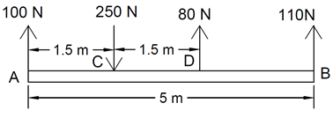  Fig.4(b) | CO2 | (10)
 |  | UNIT – III
5. | a) | Discuss the various types of beams. Classify various types of loads along with examples. | CO3 | (10)
 | b) | Find the support reaction of beam loaded as shown in the Fig.5(b).  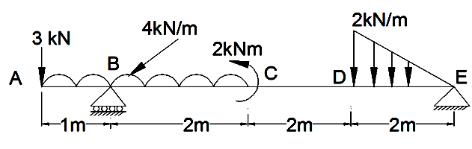  Fig.5 (b) | CO3 | (10)
6. | a) | Differentiate between statically determinate and indeterminate structure with examples. | CO3 | (08)
 | b) | Two smooth spheres rest between two vertical surfaces as shown in Fig.6(b). The larger and smaller spheres weigh respectively 1200N and 360N. The diameters of the larger and smaller spheres are 360mm and 160mm respectively. Find the reactions at 1, 2, 3 and 4. Take distance between two vertical surfaces= 450mm.  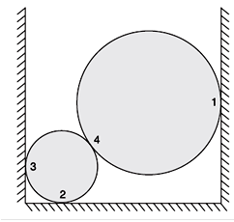  Fig.6 (b) | CO3 | (12)
 |  | UNIT – IV
7. | a) | Define centroidal axis and derive the expression for centroid of triangle. | CO4 | (10)
 | b) | Locate the centroid of the area shown in Fig. 7(b), with respect to point O.  Fig.7(b) | CO4 | (10)
8. | a) | Derive an expression for the Moment of Inertia of the circle. | CO4 | (10)
 | b) | Determine the moment of inertia of the shaded area shown in Fig.8(b) about the base AB and the centroidal axis parallel to AB.  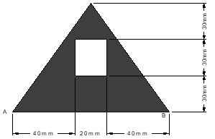  Fig.8(b) | CO4 | (10)
 |  | UNIT – V
9. | a) | Discuss the following terms:  - Limiting friction  - Angle of friction  - Coefficient of friction  - Angle of repose  - Cone of friction. | CO5 | (10)
 | b) | A block of weight W1=1290 N rests on a horizontal surface and supports another block of weight W2=570 N on top of it as shown in the Fig. 9(b). Block of weight W2 is attached to a vertical wall by an inclined string AB. Find the force P applied to the lower block, that will be necessary to cause the slipping to impend.  Coefficient of friction between blocks 1and 2 = 0.25.  Coefficient of friction between block 1and the horizontal surface 0.40. | CO5 | (10)
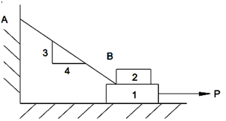
Fig.9(b)
10. | a) | Define friction and explain the different types of friction. | CO5 | (10)
 | b) | A ladder of weight 1000N and length 4m is leaning against a vertical wall making an angle of 60º with the floor. If a weight of 750 N is applied at a distance of 3m along the length from the top of the ladder, it is at the point of sliding. Determine the coefficient of friction between ladder and the floor. | CO5 | (10)

****************

